Upon reception of the Qi Sniffer did not receiver software install CD.

Began by calling distributor and company for technical assistance – still yet to be recontacted

<https://github.com/fikono/Qi_sniffer/releases> - contains relevant software for device use

Images and Qi Sniffer Set Up

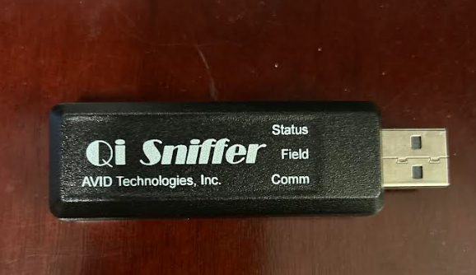

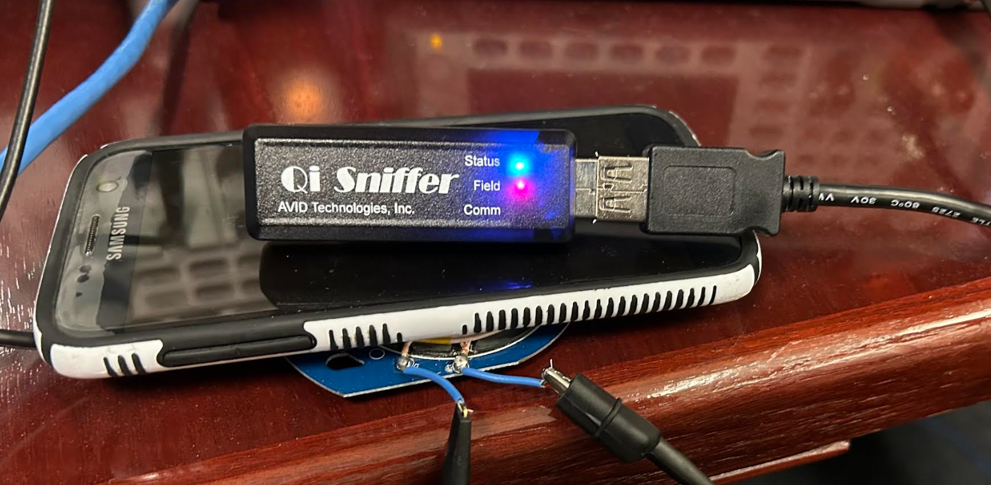

Qi Development System – Software Interface Capture

